DPJ – Practical Class 1
Technical Document – Unity 2D Fundamentals

GameObjects and Components
In Unity, a GameObject is an object that can represent different elements of a game, such as the player, a tree, a camera, or a user interface element.
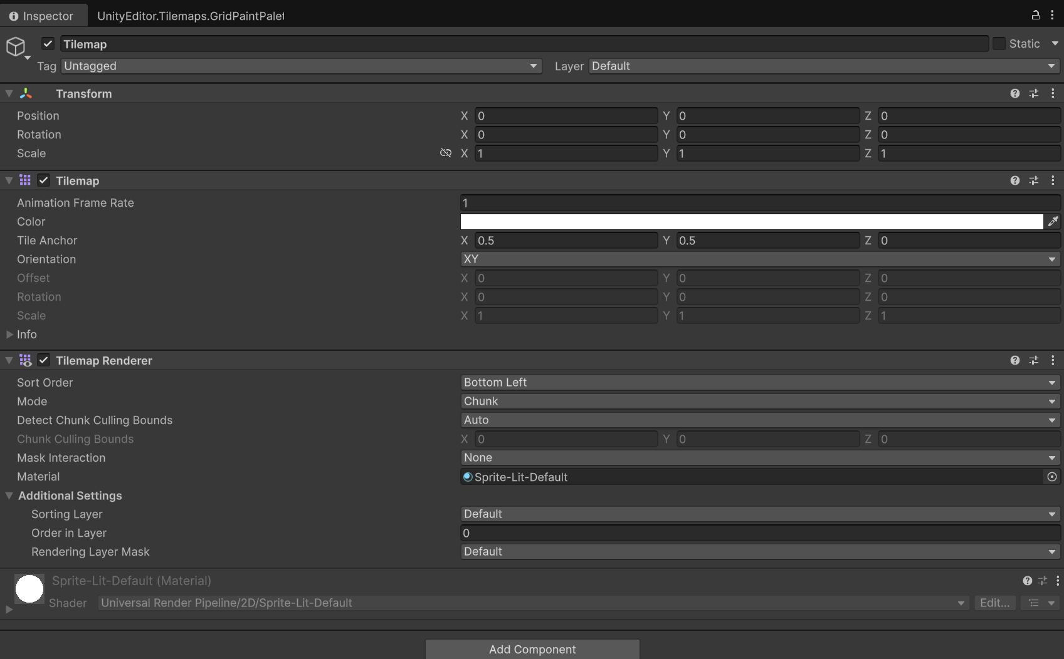
GameObjects use components to define their characteristics and functionalities.
The main and mandatory component of any GameObject is the Transform, which defines its Position, Rotation, and Scale in the scene.
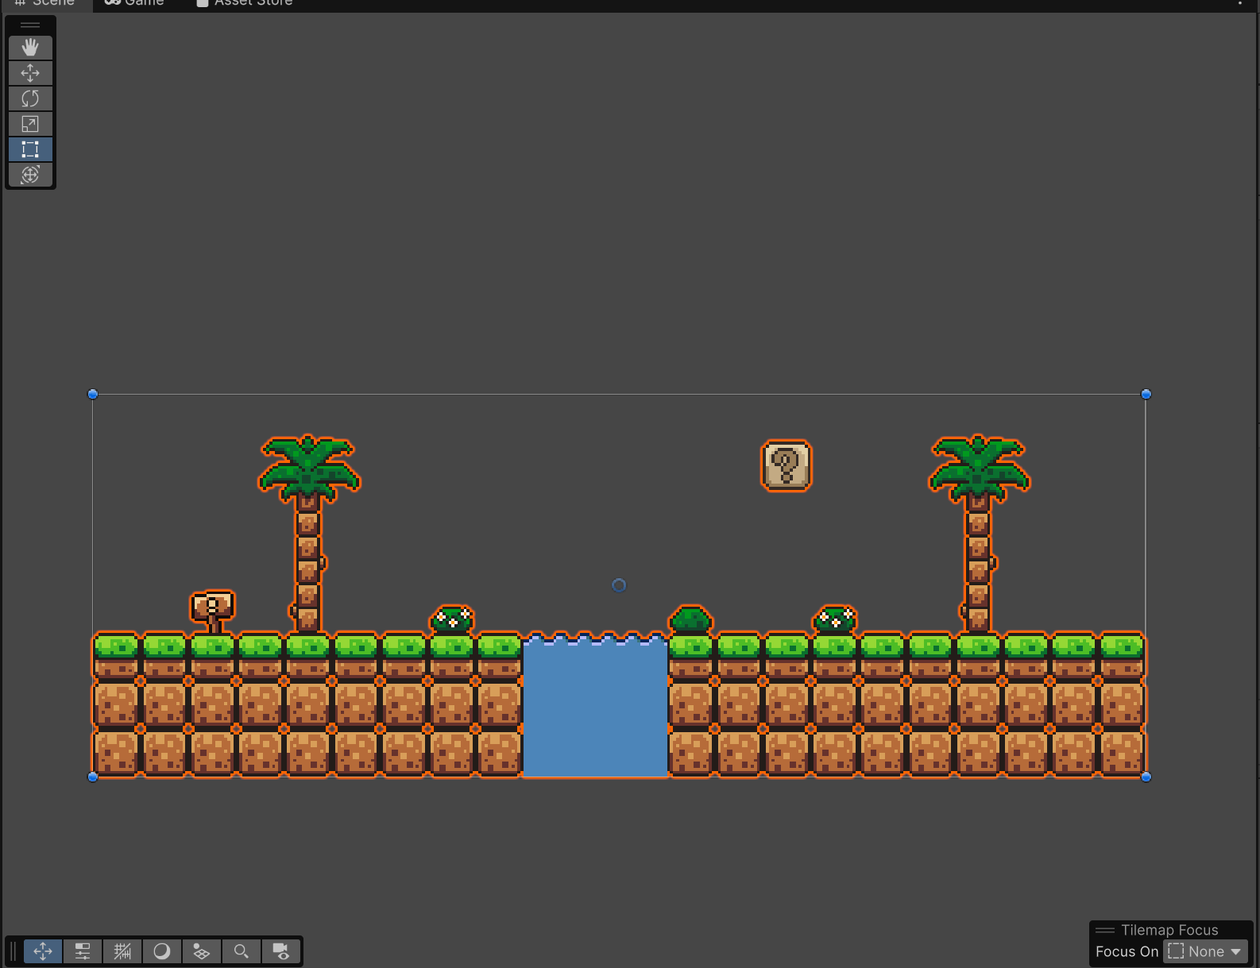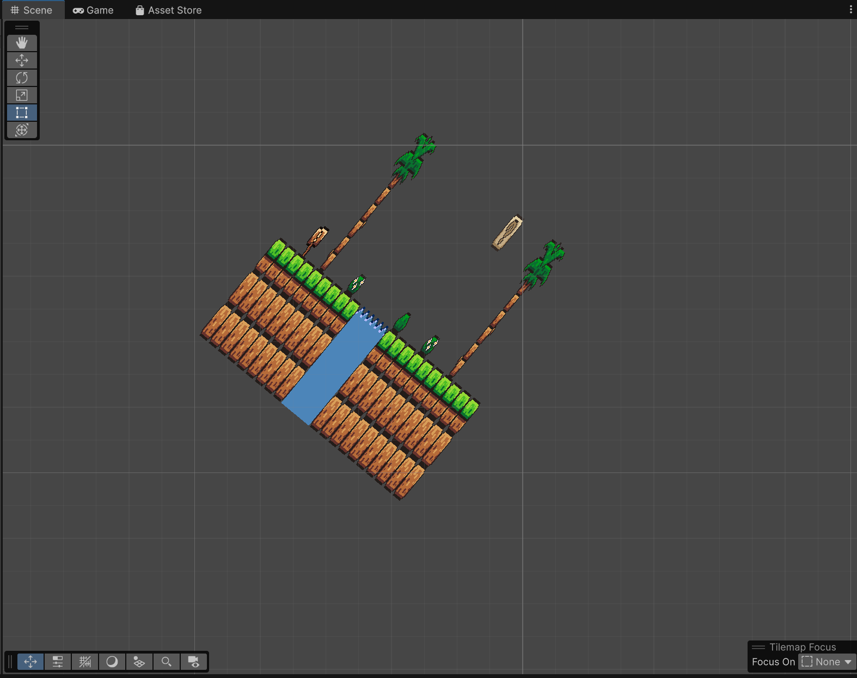
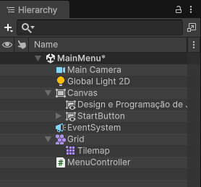

Scene Hierarchy Overview
MainMenu — The main menu scene/object. The asterisk (*) indicates there are unsaved changes.
Main Camera — The camera that renders what appears in the game.
Global Light 2D — Global light for 2D projects; illuminates the entire scene.
Canvas — The area that holds the user interface (UI) elements.
Design e Programação de Jogos — A Text/TextMeshPro element displaying the title on the start screen.
StartButton — Button used to start the game or switch scenes.
EventSystem — Manages clicks, keyboard, mouse, and interaction with UI elements.
Grid — Creates a grid for organizing 2D objects.
Tilemap — Allows building the scenery using tiles (blocks), widely used in 2D games.
MenuController — A script/component typically responsible for menu logic (buttons, scene changes, quitting, etc.).
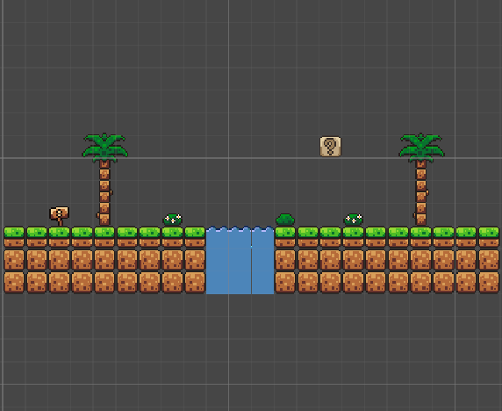

Tilemap
This component stores the tile map data and controls the physical/spatial layout of the tiles within the Grid.
- Animation Frame Rate: Sets the playback speed for animated tiles.
- Color: Applies a global tint color over all tiles on this Tilemap.
- Tile Anchor: Defines the alignment point of the tile relative to the grid cell.
- Orientation: Defines the plane on which the tiles are arranged (e.g., XY for traditional 2D games, XZ for top-down/3D views).
- Offset, Rotation, Scale: Allow you to shift, rotate, or resize all tiles on this Tilemap as a group.
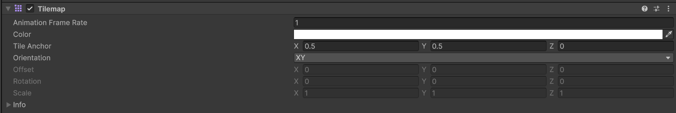

Tilemap Renderer
This component is responsible for drawing and rendering the tiles of the Tilemap on screen.
- Sort Order: Controls the order in which tiles are drawn (e.g., bottom-left to top-right). Useful for overlaps in isometric or 2D games.
- Mode: Defines how the map is rendered (Chunk renders in blocks for better performance; Individual renders tile by tile).
- Detect Chunk Culling Bounds: Defines how Unity calculates the bounds of chunks to hide what is outside the camera (culling).
- Mask Interaction: Defines how the tiles interact with Sprite Masks.
- Material: The graphics material applied to draw the tiles.
- Additional Settings (Sorting Layer & Order in Layer): Controls the rendering layer and depth priority on screen relative to other 2D objects (such as the player or enemies).
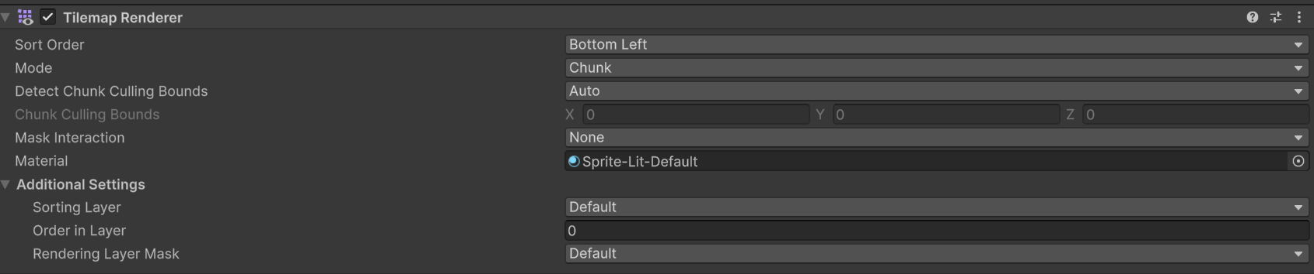

Project Files
The Project window is used to organize and manage all project files and assets. It is similar to Windows File Explorer, but inside Unity.
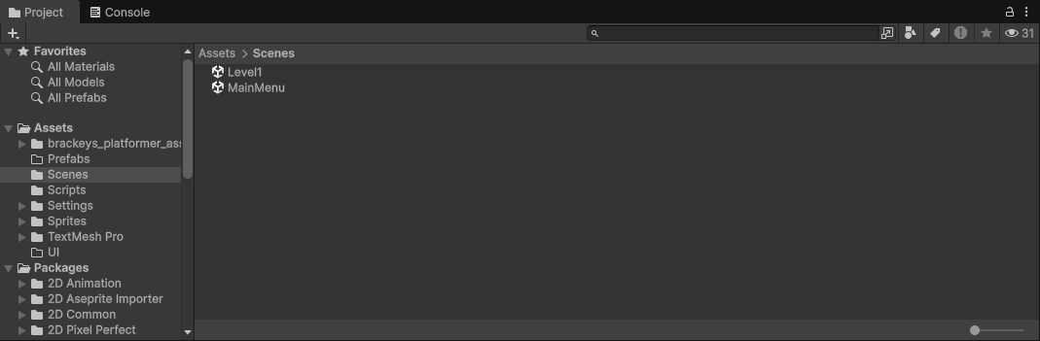

Favorites — Shortcuts to quickly find specific resources.
Assets — The main folder for project resources. Everything you create or import into the project is normally placed here.
Inside Assets you will find:
- brackeys_platformer_assets → Resources from a package/project (fonts, music, sounds, and sprites).
- Prefabs → Pre-configured objects that can be reused across scenes.
- Scenes → Contains the game scenes.
Level1 → Scene corresponding to level 1.
MainMenu → Main menu scene.
- Scripts → Contains the C# scripts that control game logic.
- Settings → Configuration files used by the project.
Lit2DSceneTemplate: A pre-configured template for a 2D scene with lighting support (Lit), ready to use when creating new 2D scenes.
Renderer2D: Defines specific rendering settings for the 2D pipeline, such as 2D light behavior, sorting layers, and shadows.
UniversalRP: The main graphics configuration file for the URP (Universal Render Pipeline). Controls the overall visual quality of the project, including shadows, anti-aliasing, HDR, and resolution.
- Sprites → 2D images used in the game.
- TextMesh Pro → Resources related to text and UI.
- UI → Resources related to the user interface.
Packages — Contains features and tools that were added to Unity through packages.

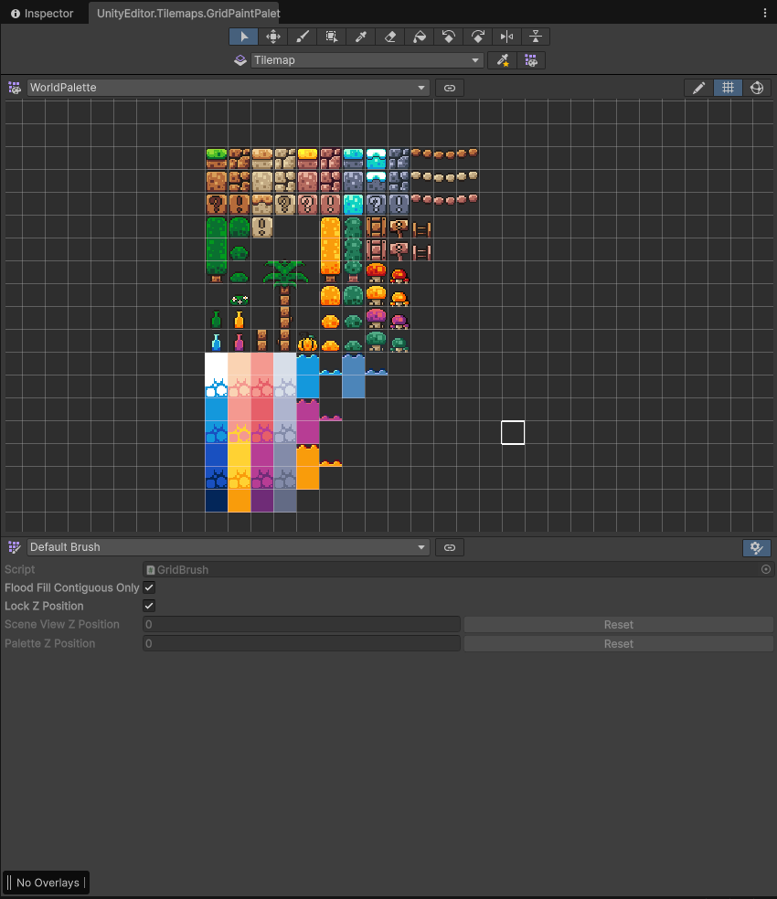

Creating 2D Levels Using Palettes
This window is the Tile Palette of Unity’s Tilemap system. It works as a painting palette for drawing 2D scenery (levels, platforms, terrain) directly in the scene.

Using the tiles from the palette, a short level design was created.

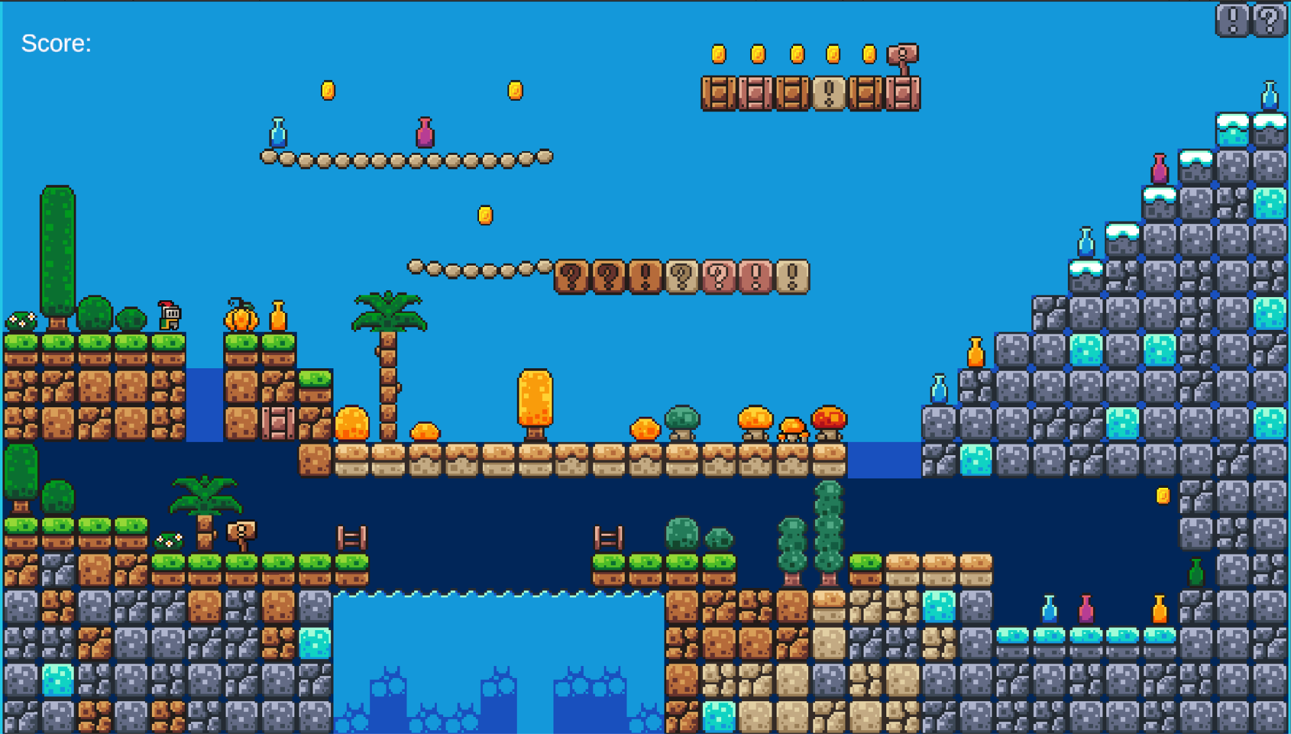
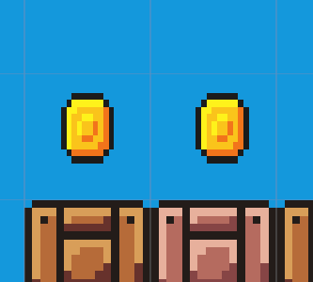

Collectible
The collectible object represents a collectible item — in this case, a coin. When it comes into contact with the player, the object is collected and the player receives 1 point. The Collider2D configured as a Trigger detects contact with the player without blocking movement.

Player

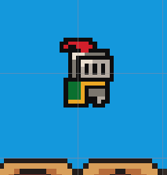
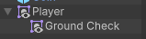
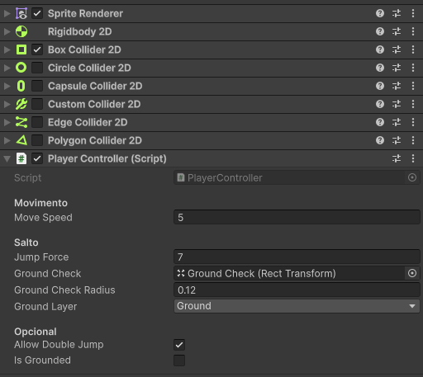

The Player is the GameObject that represents the character controlled by the player in the game. It typically includes components such as Sprite Renderer (for visual appearance), Collider2D (for collision detection), Rigidbody2D (for physics), and movement control scripts.
The Rigidbody2D component is essential for simulating the physics of the player and other GameObjects. The Body Type defines the physical behavior of the object in the simulation. There are three types:

Dynamic
- Moves under the physics simulation and is affected by forces, gravity, drag, and collisions.
- Has finite mass and all Rigidbody2D properties are available.
- Collides with all other Body Types (Dynamic, Kinematic, and Static).
- The most interactive type, but also the most performance-intensive.
- Ideal for the Player, as it allows jumping, falling under gravity, and responding to collisions with platforms and other dynamic objects.

Kinematic
- Moves under the simulation, but only under explicit user control (via code, using Rigidbody2D.MovePosition, MoveRotation, or by setting velocity).
- Not affected by forces or gravity.
- Has zero mass.
- Only collides with Dynamic bodies; does not collide with other Kinematic or Static bodies.
- More performance-efficient than Dynamic.
- Useful for moving platforms, enemies with scripted movement, or objects that the player should not be able to push physically.

Static
- Does not move under the simulation; behaves as an immovable object with infinite mass.
- Not affected by forces or gravity.
- Ideal for terrain, walls, fixed platforms, and static obstacles.
- Only collides with Dynamic bodies (other types do not interact physically with each other in the same way).
- Very performance-efficient, since the physics engine does not need to calculate movement for these bodies.

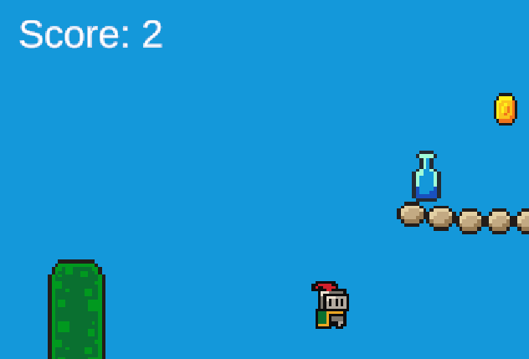
Score

A Canvas was created and, inside it, a TextMeshPro GameObject named “Score”. This text displays the player’s current score during the game.
An empty GameObject was created in the scene and the GameManager script was attached to it. The GameManager is responsible for storing the current score and updating the Score text whenever the value changes.

Respawn
An empty GameObject named “Respawn Trigger” was created. The following were attached to this object:
- The SimpleRespawn script;
- A BoxCollider2D component configured as a Trigger.
The size and position of the BoxCollider2D were adjusted to cover the area where the character can fall (for example, below the platforms or outside the level boundaries).
An empty GameObject named “Respawn Point” was positioned at the location where the player should reappear after activating the Respawn Trigger.
